345 Nursery School |  | Office:
Fitzhugh Community Clubroom |  | 69 Brodrick Road,
Fitzhugh Grove, Trinity Road |  | London, SW17 7DX
London, SW18 3SA | 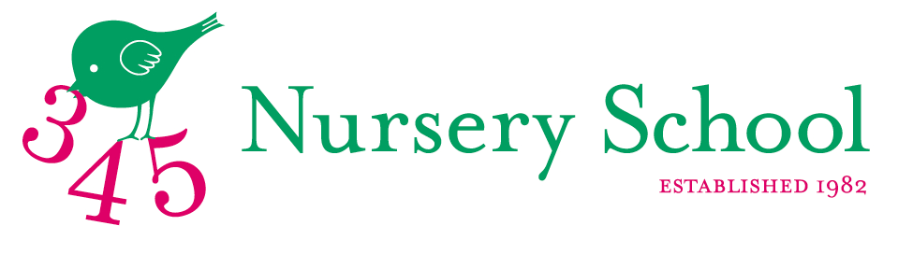 | Ofsted: EY550102
020 3633 4185 |  | Co Reg: 10394573
www.345nurseryschool.com |  | JIll@345nurseryschool.com
Registration Form - Pupils Details
Surname: | Given Name:
Date of Birth: | Childs Medical Background: e.g. asthma?
Desired Term of Entry:  Proposed Term of Leaving: | Next School (if known):
Parents Details
1. Parent’s Name: | 2. Parent’s Name:
1. Parent’s Email: | 2. Parent’s Email:
1. Parent’s Phone numbers: | 2. Parent’s Phone numbers:
1. Parent’s Profession: | 2. Parent’s Profession:
Address:

Postcode:
I/we have read and accept the Standard Terms and Conditions as printed overleaf.
Parent Signature: | Date:
Parent Signature: | Date:
Please return this form, together with your registration fee of £80.00 (non-refundable) to 345 Nursery School, 69 Brodrick Road, London, SW17 7DX or email a scanned copy to jill@345nurseryschool.com.

To pay electronically/BACS : 345 Nursery School, NatWest, Account No 28260368, Sort Code 50 21 01.

PLEASE PUT SURNAME AS PAYMENT REFERENCE AND CONFIRM TO THE SCHOOL VIA EMAIL OR ENTER REFERENCE USED HERE:

FOR OFFICE USE ONLY
Application received: | Registration Fee: | Place:  Waiting List: | Acknowledgment sent:

Standard Terms and Conditions

1. Partnership with Parents
345 aims to provide a safe and happy atmosphere in which children can explore and discover that learning is fun. The children have the chance to experience both structured and free play and to develop at their own pace. They learn a variety of social and communicative skills – sharing and caring for others, expressing their opinions, coping with their emotions, natural inquisitiveness and growing awareness of all around them. Parents (the child’s parents or guardians) are expected to support the nursery’s aims and ensure that their children maintain appropriate standards of punctuality, behaviour, discipline and hygiene.

2. Parents Authority
Parents agree to authorise 345 to act in loco parentis and authorize the nursery to take all necessary steps to safeguard and promote children’s welfare.
Parents are required to notify 345 of any change of address or contact numbers and, in strictest confidence, any change in family circumstance or court order which might affect the pupil’s welfare or happiness.

3. Health
Parents are requested to inform 345 if their child has any infectious disease or condition which may affect the child’s own health or that of other children, staff or parents.
If parents/carers cannot be contacted in the event of illness, injury or medical emergency the parents/carers consent to the child being treated by certified medical staff or taken to hospital.

4. Accidents
Whilst all reasonable care will be taken of the children at 345, the Nursery cannot accept liability in case of accidents due to something that is beyond their control.

5. Insurances
The school undertakes to maintain those insurances that are prescribed by law. All other insurances are the responsibility of the parents.

6. Entry to 345
Parents are required to complete a registration form and send it to the office together with a non-refundable registration fee. Places are offered on a first come, first served basis. Should a pupil be offered a place then the acceptance must be accompanied by a deposit, the amount of which will be in the offer letter. The deposit is held in the school’s general funds until the pupil leaves and is returned after the end of the child’s last academic term at the school less all other sums due to the school. The deposit will be retained by the school if for any reason the acceptance of a place is cancelled or the pupil does not join the school. Discretion may, however, be exercised in cases of serious illness.

7. Fees
Fees are payable on the due date set out on the invoice (usually before the first day of the academic term). A 20% late payment surcharge will be applied to any overdue amounts, unless prior arrangements have been agreed with the nursery principals. If fees remain unpaid the school reserves the right to exclude the pupil.

8. Attendance
It is our policy that all children should attend five morning sessions per week. All children are eligible for the Government Free Nursery Education Place (FNEP) funding the term following their third birthday. 345 will apply for the grant on the parents behalf and the funding will be paid directly to the nursery. Afternoon School is an optional extra. Parents can choose for their child to stay between one and five extra curriculum afternoon session for an additional fee and these places are available on a first-come first-served basis. As a result of the government new legislation introduced in September 2017 relating to the FNEP funding for all three and four year olds we reserve the right to opt out of the FNEP system should the financial sustainability of the school become untenable and will provide one terms notice should we decide to do so.
9. Withdrawal or cancellations
Once a place has been accepted one term’s notice in writing is required before the removal or non- commencement of a pupil or one academic term’s fees are payable in lieu thereof.
345 Nursery reserves the right to resign the charge of any pupil where it is in the best interests of the nursery or the welfare of the children. Similarly if the conduct of the parents is deemed to be incompatible with the aims of the nursery then the nursery reserves the right to exclude the child. In these circumstances any fees would not be refunded. The school may end the contract at any time with an academic term’s written notice to the parents.

10. Data Privacy & Protection
In the process of attending the school we will need to collect some personal data about you and your child. We keep this collection to a minimum, managing and storing this data safely and securely. We only share it with third parties that facilitate your experience, our administration, or the relevant education bodies related to the school. We do not sell or rent the information you provide us to anyone. Further details are available at www.345nurseryschool.com/dataprotection

11. Terms and Conditions
Reasonable changes may be made from time to time to these Standard Terms and Conditions, to the level of fees and to the curriculum and the structure and composition of classes and the length of nursery terms. Notice of any change will be given as soon as practicable but on some occasions this might be less than one academic term.

12. In the event that the nursery is forced to close by the Government or Public Health England due to a pandemic such as Coronavirus full fees are payable and the curriculum will be delivered virtually.

